**Cognizant - DN 4.0 I Deep Skilling**

**WEEK-6**

**ReactJS**

****Lab 1 –** Create a new React Application with the name “myfirstreact”**

**Hands On:**

Create a new React Application with the name “myfirstreact”, Run the application to print “welcome to the first session of React” as heading of that page.

**SOLUTION :**

**CODE -:**

1. **App.js**

import React from 'react';

function App() {

return (

<div>

<h1>Welcome to the first session of React</h1>

</div>

);

}

export default App;

**OUTPUT -:**

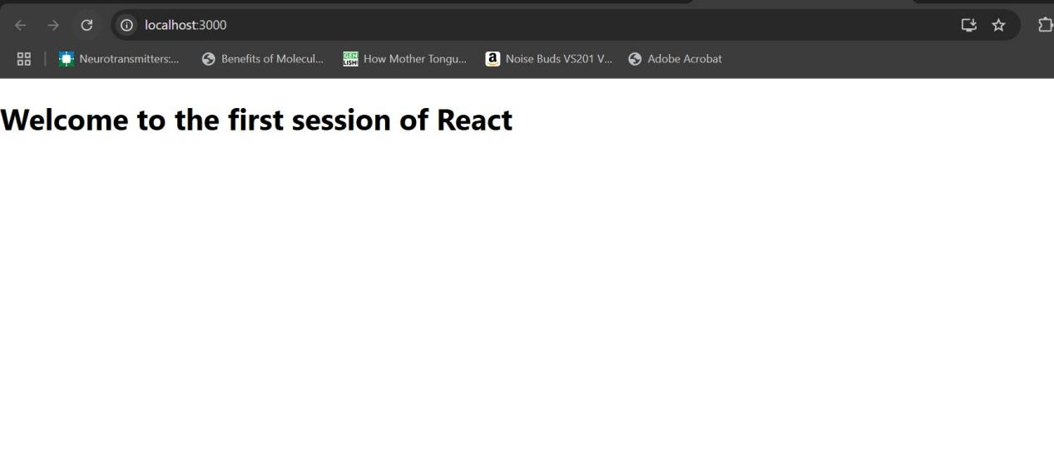

****Lab 2 –** Create a new React Application for Student Management portal**

**Hands On:**

* Create a react app for Student Management Portal named StudentApp and create a component named Home which will display the Message “Welcome to the Home page of Student Management Portal”.
* Create another component named About and display the Message “Welcome to the About page of the Student Management Portal”.
* Create a third component named Contact and display the Message “Welcome to the Contact page of the Student Management Portal”. Call all the three components.

**SOLUTION :**

**CODE -:**

1. **Home.js**

import React from 'react';

function Home() {

return (

<div>

<h2>Welcome to the Home page of Student Management Portal</h2>

</div>

);

}

export default Home;

1. **Contact.js**

import React from 'react';

function Contact() {

return (

<div>

<h2>Welcome to the Contact page of the Student Management Portal</h2>

</div>

);

}

export default Contact;

1. **About.js**

import React from 'react';

function About() {

return (

<div>

<h2>Welcome to the About page of the Student Management Portal</h2>

</div>

);

}

export default About;

1. **App.js**

import React from 'react';

import {Home} from './Components/Home';

import {About} from './Components/About';

import {Contact} from './Components/Contact';

function App() {

return (

<div>

<h1>Student Management Portal</h1>

<Home />

<About />

<Contact />

</div>

);

}

export default App;

**OUTPUT -:**

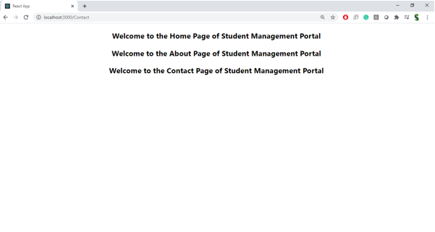

****Lab 3 –** Create a React Application for Student Management Portal named ScoreCalculatorApp**

**Hands On:**

Create a react app for Student Management Portal named scorecalculatorapp and create a function component named “CalculateScore” which will accept Name, School, Total and goal in order to calculate the average score of a student and display the same.

**SOLUTION :**

**CODE -:**

1. **Src/Components/CalculateScore.js**

import React from 'react';

import '../Stylesheets/mystyle.css';

function CalculateScore(props) {

const average = props.total / props.goal;

return (

<div className="score-box">

<h2>{props.name}</h2>

<p>School: {props.school}</p>

<p>Total Score: {props.total}</p>

<p>Goal: {props.goal}</p>

<p>Average Score: {average}</p>

</div>

);

}

export default CalculateScore;

1. **Src/Stylesheets/mystyle.css**

.score-box {

border: 2px solid #4CAF50;

padding: 20px;

margin: 20px;

background-color: #f9f9f9;

font-family: Arial, sans-serif;

}

1. **App.js**

import React from 'react';

import './App.css';

import CalculateScore from './Components/CalculateScore';

function App() {

return (

<div className="App">

<h1>Student Score Calculator</h1>

<CalculateScore

name="Riya Priyadarshini"

school="KIIT Bhubaneshwar"

total={450}

goal={5}

/>

</div>

);

}

export default App;

**OUTPUT -:**

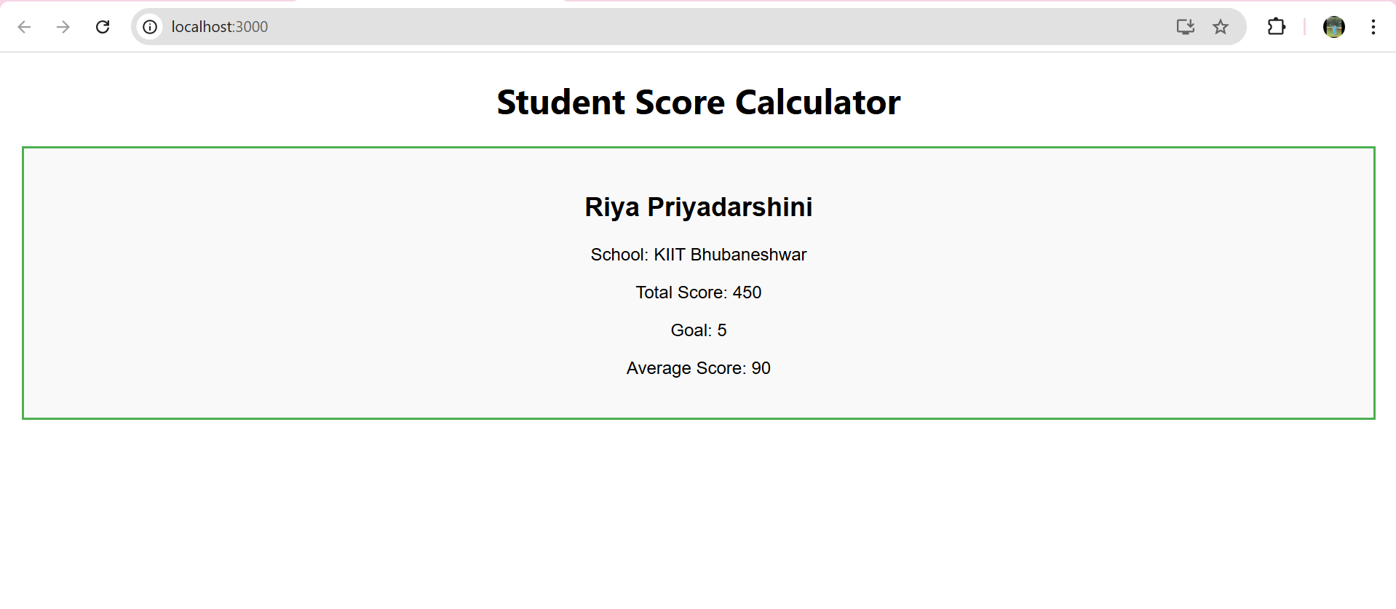

****---------------------------------------------------****

****Lab 4 –** Create a React Application named “blogapp”.**

**Hands On:**

Build a simple blog application using class components in React. You will fetch data from an external API, handle lifecycle methods like componentDidMount and componentDidCatch, and render the posts dynamically.

**SOLUTION :**

**CODE -:**

1. **Src/Post.js**

import React from 'react';

class Post extends React.Component {

render() {

return (

<div className="post">

<h3>{this.props.title}</h3>

<p>{this.props.body}</p>

</div>

);

}

}

export default Post;

1. **Src/Posts.js**

import React from 'react';

import Post from './Post';

class Posts extends React.Component {

constructor(props) {

super(props);

this.state = {

posts: [],

hasError: false

};

}

loadPosts() {

fetch("https://jsonplaceholder.typicode.com/posts")

.then(res => res.json())

.then(data => {

this.setState({ posts: data });

})

.catch(error => {

console.error("Error fetching posts:", error);

this.setState({ hasError: true });

});

}

componentDidMount() {

this.loadPosts();

}

componentDidCatch(error, info) {

alert("An error occurred: " + error.toString());

}

render() {

if (this.state.hasError) {

return <h2>Something went wrong while loading posts.</h2>;

}

return (

<div>

<h1>Blog Posts</h1>

{this.state.posts.map(post => (

<Post key={post.id} title={post.title} body={post.body} />

))}

</div>

);

}

}

export default Posts;

1. **App.js**

import React from 'react';

import './App.css';

import Posts from './Posts';

function App() {

return (

<div className="App">

<Posts />

</div>

);

}

export default App;

**OUTPUT -:**

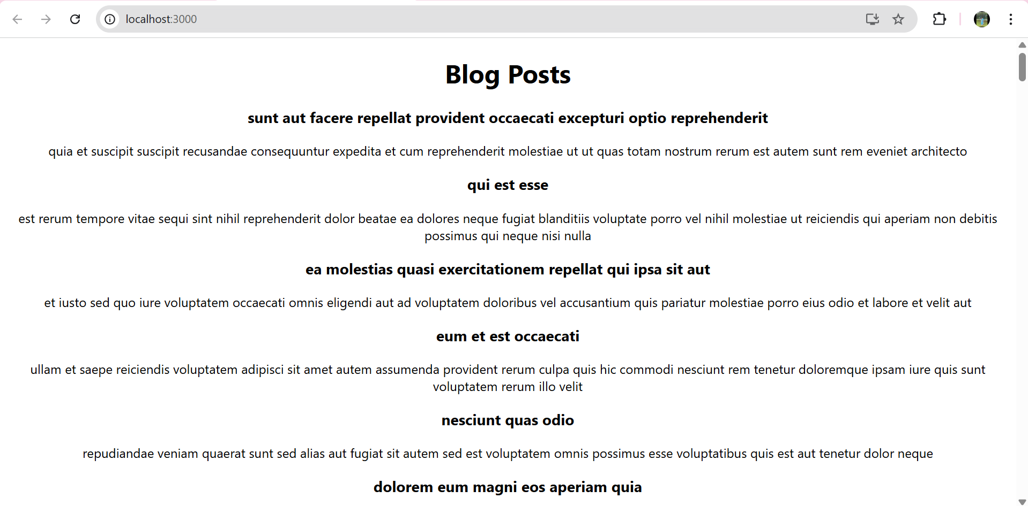

****Lab 5 – C**reate a dashboard containing the details of ongoing and completed cohorts.**

**Hands On:**

The **MyAcademy team at Cognizant** is building a dashboard to show **ongoing and completed cohorts**.  
You have been given a basic React app that displays cohort details.  
Your task is to style the cohort components using **CSS Modules** and **inline styles**.

**SOLUTION :**

**CODE -:**

1. **CohortDetails.module.jss**

.box {

width: 300px;

display: inline-block;

margin: 10px;

padding: 10px 20px;

border: 1px solid black;

border-radius: 10px;

}

dt {

font-weight: 500;

}

1. **CohortDetails.jss**

import React from 'react';

import styles from './CohortDetails.module.css';

function CohortDetails(props) {

return (

<div className={styles.box}>

<h3 style={{ color: props.status === 'ongoing' ? 'green' : 'blue' }}>

{props.name}

</h3>

<dl>

<dt>Duration:</dt>

<dd>{props.duration}</dd>

<dt>Status:</dt>

<dd>{props.status}</dd>

</dl>

</div>

);

}

export default CohortDetails;

1. **App.js**

import React from 'react';

import './App.css';

import CohortDetails from './CohortDetails';

function App() {

return (

<div className="App">

<CohortDetails name="React Bootcamp" duration="6 weeks" status="ongoing" />

<CohortDetails name="Java Basics" duration="4 weeks" status="completed" />

<CohortDetails name="Advanced SQL" duration="1 week" status="completed" />

<CohortDetails name="Web API" duration="2 weeks" status="completed" />

<CohortDetails name="Nunit and Moq" duration="2 weeks" status="completed" />

</div>

);

}

export default App;

**OUTPUT -:**

